# **Design Your Project – Best Practices**

**1. Clean and Simple Navigation**

* Ensure the navigation is intuitive and easy to understand
* Use clear and descriptive labels for the menus

**2. Consistency**

* Apply a consistent design across all pages and interface elements
* This includes colors, fonts, buttons, and icons
* Consistency helps users navigate more easily

**3. Simplify**

* Avoid overwhelming the user with too much information and elements
* Keep the interface clean and simple, focusing on core functions and content

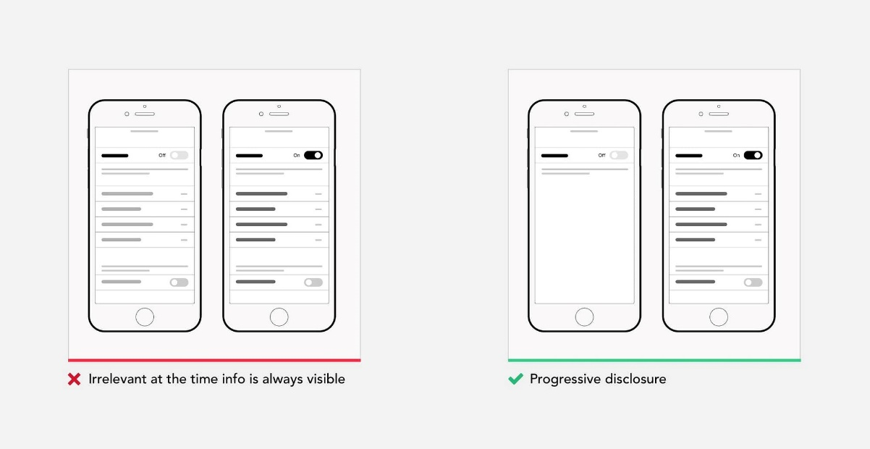

**4. Visual Hierarchy**

* Use visual hierarchy to guide users' attention to the most important elements
* Utilize sizes, colors, and positioning to highlight key elements and content

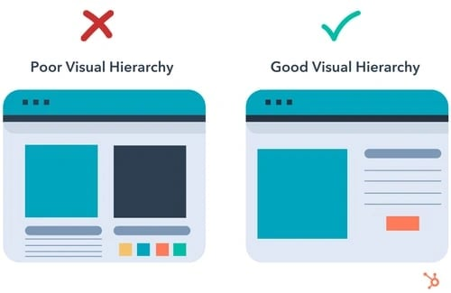

**5. Readability**

* Use easy-to-read fonts and sufficiently large text size
* Ensure adequate contrast between text and background

**6. Easy to Find Call-to-Action Buttons**

* Provide clearly labeled and easily accessible action buttons (like "Buy Now," "Sign Up," "Learn More")
* Use contrasting colors to make them visible



**7. Interactive Elements**

* Provide feedback when interacting with interactive elements like buttons, links, and forms
* This can include color changes, animations, or other visual indicators



**8. Whitespace**

* Use sufficient white space to make content easier to perceive and to improve the overall aesthetic of the site

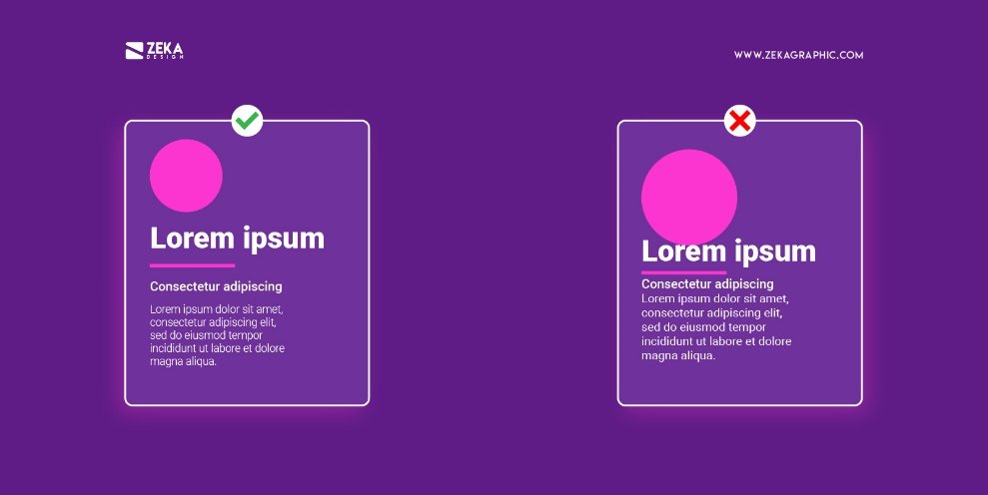

**9. Intuitive Icons**

* Use easily recognizable icons that clearly indicate their function
* Avoid complex icons that may confuse users

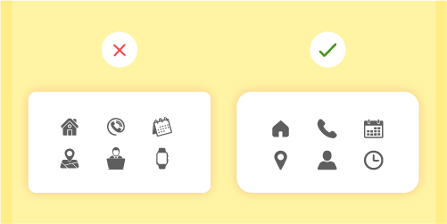

**10. Use of Visuals**

* Utilize high-quality images and graphics that complement the content and enhance the visual appeal of the site
* Avoid excessive use of stock images

**11. Color Selection**

* Create a limited color palette that includes primary, secondary, and accent colors
* Ensure sufficient contrast
* Use accent colors to highlight important elements and neutral colors (like white, black, gray) for background and other secondary elements

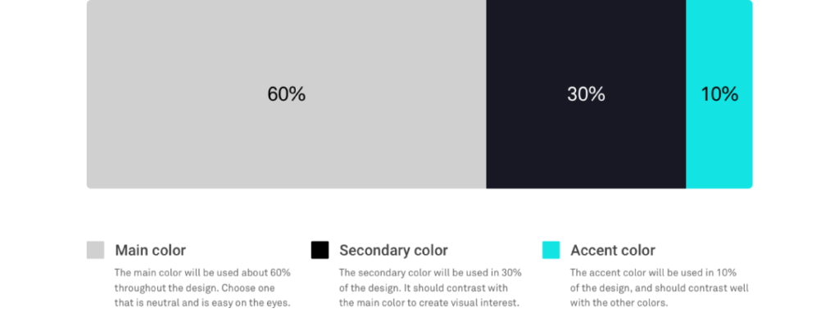

**12. Bonus Resources**

* <https://digitalsynopsis.com/design/ui-ux-design-tips/>
* <https://www.paulinewiles.com/articles/12-done-for-you-website-color-schemes>
* <https://wpmudev.com/blog/hack-your-way-to-great-design-basic-design-principles-for-wordpress-developers/>
* <https://yellowchalkuiux.medium.com/8-golden-rules-of-interface-design-dff2133c4a66>